

Safeguarding Children
Inter-Agency
Foundation Training

Russ Cooper

www.GSCB.org.uk
Revised May 2011

Index

1. Aims 1
2. Principles in child protection work 1
3. Child protection legislation & significant events 2
4. The concept of significant harm 3
5. Glossary of terms 4
6. Victoria Climbie 4
7. Every Child Matters – The next steps 5
8. Thresholds for intervention 5
9. Normal parenting? 7
10. Definitions of child abuse 7
- Physical abuse 7
- Emotional abuse 7
- Sexual abuse 8
- Neglect 8
- 4 diagnostic points 8
- Group exercise 9
11. Indicators of physical abuse 9
12. Non-accidental injuries 10
13. Possible behavioural indicators of physical
Abuse 11
14. Physical indicators of physical abuse 12
15. Risk factors associated with physical and
emotional abuse 12
16. Indicators of child sexual abuse 13
17. Indicators suggesting a high likelihood of
Sexual abuse 14
18. Indicators suggesting cause for concern
And need to investigate
19. Remember – hints 14
20. Sexual behaviour that should cause
Concern 15
21. Sources of stress for families 16
- Social exclusion 16
- Domestic violence 16
- Mental illness of parent or carer 17
- Parental drug and alcohol misuse 17
- Children with disabilities 17
22. What to do – your role in protecting children 18
- Reporting suspected abuse 20
23. 7 Golden Rules of information sharing 21
24. Common assessment framework 22
25. Child protection processes 23
- Professional concerns 23
- Making a referral 24
- Child protection conference process 25
- Allegations management 26

Personal standards exercise 27
Some do’s and don’ts 28

1. Aims

- To raise general awareness of Child Protection issues

- To look at the categories of abuse and the signs which might alert you to possible abuse

- To look at what you do if you think a child is being abused - and the child protection procedures to follow

2. Principles in Child Protection Work

- The protection and welfare of the child must be the paramount consideration in all action.

- All professionals in contact with children should be aware of the possibility of child abuse and neglect and the need to maintain vigilance at all times.

- Procedures must be followed to ensure prompt and effective help to children and their families.

- Children must be listened to, taken seriously and their comments fully evaluated.

- All those involved in child protection cases, including children, families and individuals alleged to have been responsible for harm and neglect, must be treated with respect.

- Parents, carers and children must be kept fully informed and, where appropriate, involved in decision making.

- Child Protection services should be available and accessible to all members of the community.

- Joint agency training for staff is a vital part of the child protection process.

- Staffs working in child protection are entitled to support and supervision from their agencies.

- Information sharing between agencies is of crucial importance.
3. Child Protection -The Legislation & Significant Events

Significant events

* The At Risk Register 1975

As a result of the death of Maria Colwell (1973)

1986 Publication of Child Abuse – Working Together (consultation document)
Recommending greater Intervention by the state – (re: Jasmine Beckford)

* 1988 Public Enquiry into the Cleeveland
case

Children’s Act 1989

Brought together public & private law

· Ensured the Child’s Welfare is Paramount

· The need for Agencies to work together

· Introduced the concept of Parental Responsibility

· Introduced the concept of Significant Harm

Children’s Act 2004

- Key messages

· The safeguarding & promoting the welfare of each child

· The child being the centre of endeavours

· All agencies and their staff must work together

4. THE CONCEPT OF SIGNIFICANT HARM

The Children 1989 introduced the concept of significant harm as the threshold which justifies compulsory intervention in family life in the best interest of children. The Local Authority is under a duty to make enquiries where it has reasonable cause to suspect a child is suffering or is likely to suffer significant harm (section 47).

Harm is defined by the Children Act 1989 as:

- Ill treatment (including sexual abuse and physical abuse)

- Impairment of health (physical or mental) or development (physical, intellectual, emotional, social or behavioural) as compared to a similar child.

To understand the threshold for significant harm it is necessary to consider:
- The family concept
- The child’s development with the context of the family and wider social environment
- Any special needs, such as a medical condition, communications difficulty or disability that may effect the child’s development and care within the family
- The nature of harm, in terms of all treatment or failure to provide adequate care
- The impact on child’s health and development
- The adequacy of parental care.

The child’s reaction and perceptions must also be taken into account:-

N.B - The Adoption and Children’s Act 2002 extends the definition of harm within the Children’s Act 1989 to include:
”impairment suffered from seeing or hearing the ill –treatment of another”

This brings those children witnessing or experiencing domestic violence into the child protection arena.

5. Glossary of Terms

Section 47:

From the 1989 Children’s Act,

“local authority has responsibility to provide services where there is actual or potential risk of significant harm”

(s47. Children in need of protection)

Section 17:

From the 1989 Children’s Act,

“local authority has responsibility to provide services where the health and development of children is being avoidably impaired”

(s17. Children in need)

6. Victoria Climbie 1991-2000
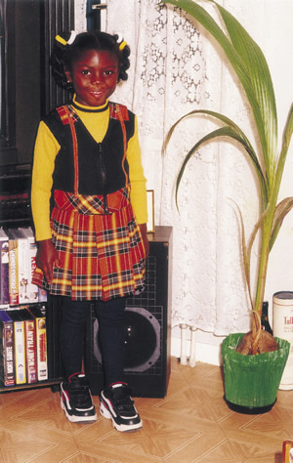
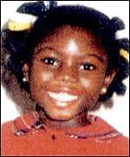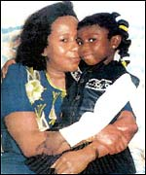
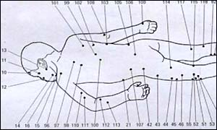

128 Recorded Injures

7. EVERY CHILD MATTERS – THE NEXT STEPS

The government’s Green Paper aims to ensure every child and young person has the opportunity to fulfil their potential.

It sets out 5 outcomes for children

(To be known as “Well-being”)

Being healthy

Staying safe

Enjoying and achieving

Make a positive contribution

Economic well being

8. Thresholds For Intervention

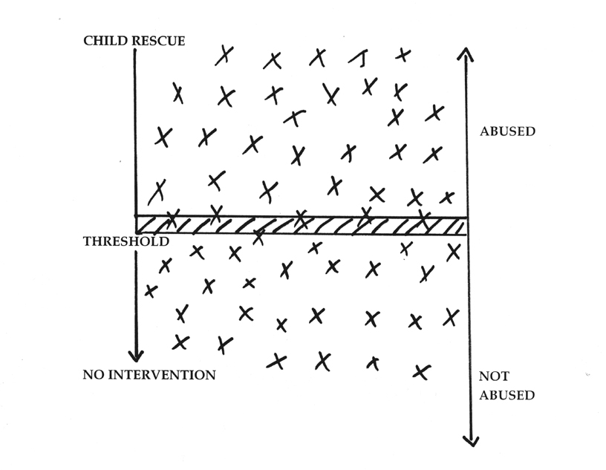
Dartington Research 1995

Dartington research suggests four factors which influence where we place thresholds:

1) MORAL AND LEGAL CONCERNS
Societal Influences

2) PRAGMATIC ISSUES
Will intervention help?

3) OUTCOME EVIDENCE
What research tells us is harmful to children

4) USER PERSPECTIVES
What children and parents consider helpful

All 4 are inter-linked and will influence where we place our threshold

Thresholds are a way of gate keeping or filtering at different stages of the child protection process.

They determine the key questions:

1. When to define something as abuse

2. When to intervene i.e. when to speak to parents, refer to social
services (CYPD) and decide it’s child protection not child & family support

Thresholds prompt intervention

Notes

9. Normal Parenting?

Smacking Frequency:
97% of 4 year olds
75% of babies under 1
50% of 11 year olds
15% of all children had suffered severe physical punishment
83% of mothers believed in smacking
(Parental definitions of smacking ranged from a tap to a severe beating)
Nobes & Smith 1997

In a poll of 600 parents for ITV’s “This Morning” programme, they found that 75% of parents had smacked their children. (Oct 2004)
Children Act 2004
“It is an offence to hit a child if it causes mental cruelty or leaves a mark on the skin.”

10. Definitions of Child Abuse
[Working Together to Safeguard Children (DCSF 2010)]

Physical abuse

1.33 Physical abuse may involve hitting, shaking, throwing, poisoning, burning or scalding, drowning, suffocating, or otherwise causing physical harm to a child. Physical harm may also be caused when a parent or carer fabricates the symptoms of, or deliberately induces, illness in a child.

Emotional abuse

1.34 Emotional abuse is the persistent emotional maltreatment of a child such as to cause severe and persistent adverse effects on the child’s emotional development. It may involve conveying to children that they are worthless or unloved, inadequate, or valued only insofar as they meet the needs of another person. It may include not giving the child opportunities to express their views, deliberately silencing them or ‘making fun’ of what they say or how they communicate. It may feature age or developmentally inappropriate expectations being imposed on children. These may include interactions that are beyond the child’s developmental capability, as well as over-protection and limitation of exploration and learning, or preventing the child participating in normal social interaction. It may involve seeing or hearing the ill-treatment of another. It may involve serious bullying (including cyberbullying), causing children frequently to feel frightened or in danger, or the exploitation or corruption of children. Some level of emotional abuse is involved in all types of maltreatment of a child, though it may occur alone.

Sexual abuse

1.35 Sexual abuse involves forcing or enticing a child or young person to take part in sexual activities, not necessarily involving a high level of violence, whether or not the child is aware of what is happening. The
activities may involve physical contact, including assault by penetration (for example, rape or oral sex) or non-penetrative acts such as masturbation, kissing, rubbing and touching outside of clothing. They may also include non-contact activities, such as involving children in looking at, or in the production of, sexual images, watching sexual activities, encouraging children to behave in sexually inappropriate ways, or grooming a child in preparation for abuse (including via the internet). Sexual abuse is not solely perpetrated by adult males. Women can also commit acts of sexual abuse, as canother children.

Neglect

1.36 Neglect is the persistent failure to meet a child’s basic physical and/or psychological needs, likely to result in the serious impairment of the child’s health or development.
Neglect may occur during pregnancy as a result of maternal substance abuse. Once a child is born, neglect may involve a parent or carer failing to:
●provide adequate food, clothing and shelter (including exclusion from home or abandonment);
●protect a child from physical and emotional harm or danger;
●ensure adequate supervision (including the use of inadequate care-givers);
●ensure access to appropriate medical care or treatment.

It may also include neglect of, or unresponsiveness to, a child’s basic emotional needs.
Neglect is the most widely reported category of abuse.

It may also include neglect of, or unresponsiveness to, a child’s basic emotional needs.
Notes

11. Signs and Symptoms of Abuse

4 Key Diagnostic points

Firstly – you are told that abuse has occurred

Secondly – does the history / explanation match the observed injury

Thirdly – is there increased potential for violence

Fourthly – there are observable signs

Group Exercise
Emotional Behavioural Physical

11. Indicators of physical abuse
Most healthy children will collect bruises or other injuries from time to time. Accidental bruises will usually occur on the skin where it is covering bony prominences (e.g. shin, forehead, elbow, hip bone). Also, a very small number of children may suffer from rare conditions, like haemophilia or brittle bone disease, which makes them more susceptible to bruising and fractures.
The lists of “Indicators of Abuse” which follows though not exclusive or in themselves always diagnostic of abuse are characteristic of non-accidental injury.
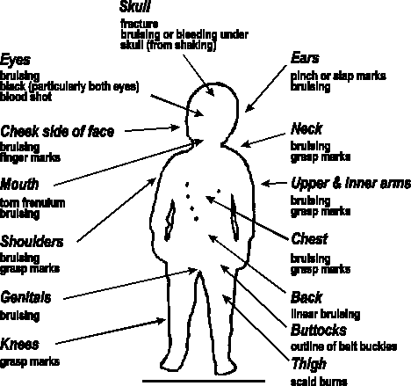

Notes

12. Non accidental Injury’s
Particular attention should be paid if:
Bruises are:
◆ frequent
◆ patterned (e.g. finger and thumb marks)
◆ old and new (note colour)
◆ in unusual positions
(Note developmental level and activities of the child)
Burns and scalds have:
◆ clear outline
◆ no or few splash marks
◆ unusual positions
◆ indicative shapes (e.g. cigarette, electric fire)
Injuries maybe suspicious if:
◆ bite marks
◆ large and deep scratches
◆ incisions
Fractures if:
◆ numerous
◆ unreported
◆ healed at different times
◆ child under two
Other Indicators of possible Abuse

◆ Delay in seeking medical attention
◆ No explanation or inadequate explanation of injuries
◆ Child/parent/witness reports abuse
◆ Changing explanation of injuries
◆ Recurrent injuries - particularly if forming a pattern (e.g. always on Mondays)
◆ Inadequate parental concern
◆ Multiple injuries that occurred at different dates
◆ Child may be failing to thrive for no apparent reason

13. Possible Behavioural Indicators of Physical Abuse
- Fear of adults generally or of certain adults in particular
- Poor peer relationships
- Social isolation and withdrawal
- Aggression and acting out/pseudo maturity
- Frozen awareness (a combination of a lack of expression, lethargy and watchfulness)
- Detachment or indiscriminate attachment
- Eating disorders
- Sleep disturbance
- Running away
- Sudden changes in behaviour or poor school performance
- Psychosomatic complaints

Self destructive behaviour (self mutilation, substance abuse and suicide)
14. Physical Indicators of Physical Abuse
- Hand slap marks

- Grip marks, often visible if the child has been shaken and sometimes the only physical indicator of sexual abuse if a child has been forcibly held by the abuser

- Bruising in unusual positions, including the genital area if sexual abuse has occurred

- Black eyes, often cause by direct blows, although they may also result from an accidental bang to the nose or forehead

- Burns and scalds in unusual positions or in definite shape, accidental burns usually leave splash marks (dipping scalds are more likely to have been caused deliberately)

- Bite marks, often evidence as bruising, and teeth marks (a doctor would be able to tell whether the bite was inflicted by an adult or another child

- A torn frenulum (piece of skin inside the upper lip) may be result of a direct blow or of an object, such as feeding bottle, being forced into the mouth

- Multiple fractures or fractures of varying ages (x-ray reveal past fractures or spiral fractures caused by the twisting of the limb)

- Poisoning, such as making a child drink bleach for swearing, or take alcohol or medicine to sleep or be quiet

- Injuries to the genital or rectal area, including unexplained soreness or bleeding, sexually transmitted diseases and pregnancy, may be indicators of sexual abuse

15. Risk Factors Associated with Physical & Emotional Abuse
While none of these indicators would be 100% diagnostic of abuse in itself, each would be a cause for some concern that would need to be explored with the family and with other agencies.

Parental  Drug and alcohol misuse  Mental illness  Isolation or lack of support  Young parents  Lack of attachment/  unresponsive to child’s needs  Lax and inconsistent parenting  History of violence/abuse of children  Inappropriate expectation  Abused themselves | Child  Has a disability  Demanding  as a baby  Under 2’s are consistently  the most vulnerable  Child or siblings previously  on child protection register  Premature birth or poor  feeders/sleepers  Poor bonding  Failure to thrive
Social - linked to stress factors
Unemployment
Bad housing
No income
Domestic violence
Unwanted pregnancy
Recent accident/ill-health

16. Indicators of child sexual abuse

A child’s verbal allegations must always be treated with the greatest respect. Children are entitled to be listened to and to have their allegations treated seriously. Although there can be occasions when children invent allegations, as a result of adult pressures or for a

variety of other reasons, research suggests that such fabricated allegations are rare and
that children are in fact more likely to claim they are not being assaulted when they are than vice versa.
Once concerns are reported it is important that the indicators are weighed in terms of significance and in the context of the child’s life, before the assumption is made that the child is or has been sexually assaulted. Some indicators take on greater or lesser weight depending on the child’s age. It is essential you do not question the child but record carefully what is said and contact Social Services. Do not discuss with a suspected abuser.
17. Indicators suggesting that there is a high likelihood of sexual abuse

◆ The child’s own verbal allegation (“disclosure”) that an assault has occurred
◆ Physical symptoms for which the only explanation is sexual activity, including genital tearing, Sexually Transmitted Diseases and pregnancy in younger children
◆ Children’s Sexual Abuse of other children
◆ Suicide attempts
◆ Compulsive masturbation in an inappropriate setting
◆ Vivid details of sexual activity in talk/play/drawings, showing awareness of penetration, ejaculation, oral or anal sex (younger children)
18. Indicators suggesting cause for concern and a need to investigate – in order to find a satisfactory explanation

◆ Pregnancy and Sexually Transmitted Diseases
◆ Drug and alcohol abuse
◆ Persistent running away
◆ Sexualised stories/poems
◆ Self mutilation
◆ Chronic urinary / vaginal infections or soreness
◆ Exposure of genitals
◆ Eating Disorders
◆ Clinical Depression
◆ Unexplained money or gifts
◆ Fear of particular people or situations
◆ Obsessional behaviour
◆ Developmental regression

19. Remember

- Take what the child or young person says seriously.

- React calmly because over-reacting can frighten the young person and compound feeling of guilt.

- Tell the young Person they are not to blame. Young people are the victims of child abuse, never the cause.

- Explain to the young person what will happen next as early as possible.

- Check your understanding with the young person of what has happened if you are not clear what the young person is telling you.

- Keep questions to a minimum and never lead the young person as leading questions may invalidate the young person’s testimony in court.

- Use the words the young person uses.

- Record your conversation with the young person as soon as possible after the event.

Notes

20. Sexual Behaviour that should Cause Concern

- There was force involved in any sexual act.

- There was abusive, sadistic or ritualistic sexual behaviour

- A child exhibited inappropriate sexual behaviour for his/her age.

- An older child becomes sexual with a child much younger (four year’s difference or more).

- There was an element of secrecy which was not appropriate

- There was compulsive public masturbation

21. Sources of stress for Families

Many families manage to bring up their children in a warm loving supportive environment in which the child’s needs are met and they are safe from harm. For some, sources of stress within the families can have a negative impact on a child’s health, development and well being. Research tells us that such sources of stress may include the following:

SOCIAL EXCLUSION
Many families are socially disadvantages and directly affected by poverty. They may live in poor housing be vulnerable to accidents, have poor diet and health problems, lack of access to good educational opportunities or leisure facilities. Racism and racial harassment are an additional source of stress.

DOMESTIC VIOLENCE
Prolonged or regular exposure to domestic violence can have a serious impact on a child’s development and emotional wellbeing, even when a parent tries to protect his/her children. There are three significant ways that domestic violence can have an impact:

- As a threat to an unborn child where physical assault poses a threat to foetus and mother.
- Through physical injury where children have got in the way or been injured intentionally.

3. By causing emotional harm and damage to children who witness the physical and emotional suffering of a parent.

The negative impact of domestic violence is made worse when the violence is combined with drink or drug abuse. Up to 75% of children who are subject to Child Protection Plans live in families where domestic abuse is prevalent.

MENTAL ILLNESS OF A PARENT OR CARER
It is important to stress that mental illness does not necessarily have an adverse effect on a child but it may restrict a child’s social and recreational activities especially if the child takes responsibility for caring for their parent in a way that is inappropriate to their age. If depressed, a parent may neglect their children’s physical and emotional needs. Occasionally a child may be at risk of extreme violence or even death. Out of 100 recent child death reviews (Cleaver H et al 1999), mental illness was found to be a factor in a third of them.

DRUG AND ALCOHOL MISUSE

- Drug and alcohol misuse be a parent or carer do not necessarily mean a child’s development or well being will be harmed bit it can impact on a child in a number of ways
- Maternal substance abuse may impair an unborn child’s development
- Misuse of drugs or alcohol may put a child at risk of physical injury, distress or neglect
- Children may be at risk of physical harm by inadvertently taking drugs or picking up needles not kept safely out of reach.

CHILDREN WITH DISABILITIES

Children with disabilities are 3 times more likely to suffer abuse than other children, because:
- Thresholds for referral likely to be higher
- Difficulties with communication
- Under represented in Child Protection figures
- Disability can mask abuse, and may provide opportunity for rational explanation

22. What to do - your role in protecting children at risk
As someone who comes into frequent contact with young people, you will be aware that many children each year are abused and neglected.
You may come across situations yourself when you have suspected abuse but have been uncertain how to act for the best.
These handouts aim to help you when you are faced with a child who you think may have been abused or neglected. It is based on Gloucestershire Safeguarding Children’s Board and the South West Safeguarding and Child Protection Group procedures.
The GSCB procedures manual can be downloaded electronically from the GSCB website: www.GSCB.org.uk
Notes

Reporting Suspected Abuse - Checklist
Before you contact someone to report your suspicions, it will help to spend a few moments preparing yourself, and making some brief notes on what you need to cover. The list below is one suggestion; however, do not be put off making contact if you are not sure about all the details.

Name of child

Age / Date of birth

Parent(s)/Carer(s) names

Home address and telephone number

Are you reporting just your own concerns or passing those of someone else?

Brief description of what has prompted your concerns: include dates, times of any specific incidents

Any physical signs? Behavioural signs? Indirect signs?

Have you spoken to the child? If so, what was said?

Have you spoken to the parent(s)? If so, what was said?

Has anyone been alleged to be the abuser?

Have you consulted anyone else? Give details

Any other information or views you may have that would help decide what action needs to be taken?

Are you reporting just your own concerns or passing those of someone else?

Brief description of what has prompted your concerns: include dates, times of any specific incidents

Any physical signs? Behavioural signs? Indirect signs?

Have you spoken to the child? If so, what was said?

Have you spoken to the parent(s)? If so, what was said?

Has anyone been alleged to be the abuser?

Have you consulted anyone else? Give details

Any other information or views you may have that would help decide what action needs to be taken?

EXAMPLE CHECKLIST

23. 7 Golden Rules of Information Sharing

- The Data Protection Act (1998) is not a barrier to sharing information
- Be open and honest
- Seek advice
- Share with consent where appropriate
- Consider safety and well-being
- Necessary, proportionate, relevant, accurate, timely and secure
- Keep a record

You are asked to, or wish to, share information
Is there a legitimate purpose for sharing information?
No
Do not share
Yes
No
Yes
No
Yes
You can share
No
No
Yes
Yes
Yes
No
Does the information enable a person to be identified?
Have you properly recorded the information sharing decision, in line with your agency’s policies and protocols?
Is the information confidential?
Do you have consent?
Is there sufficient public interest to share?
Is it the right information, to the right person, in the right way?
Do you have a statutory obligation or court order to share?

24. Common Assessment Framework

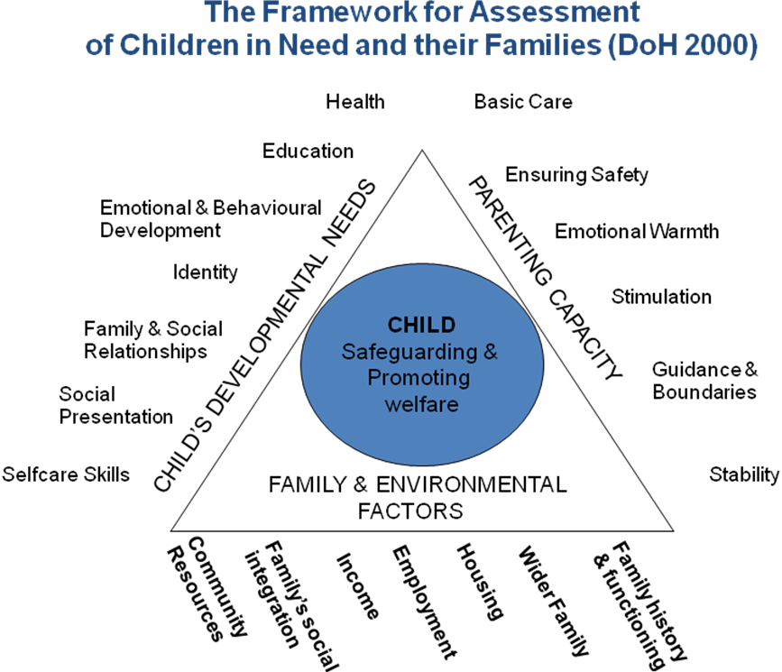

Notes

25. Child Protection Processes

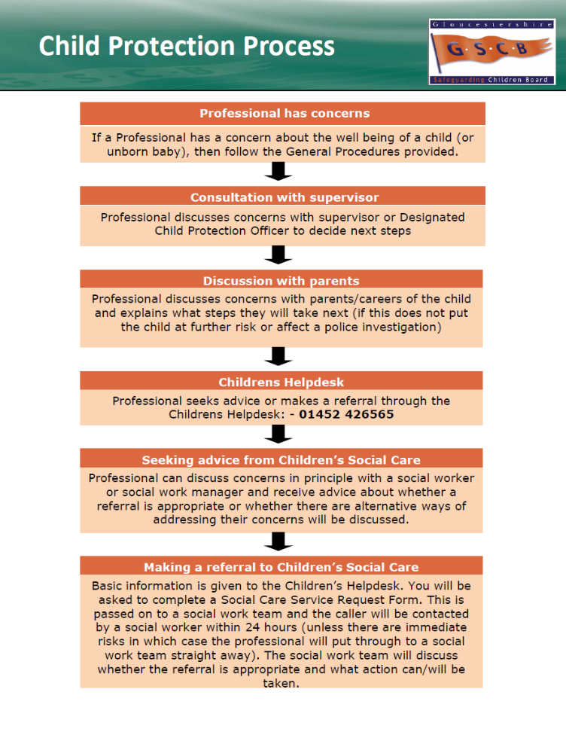
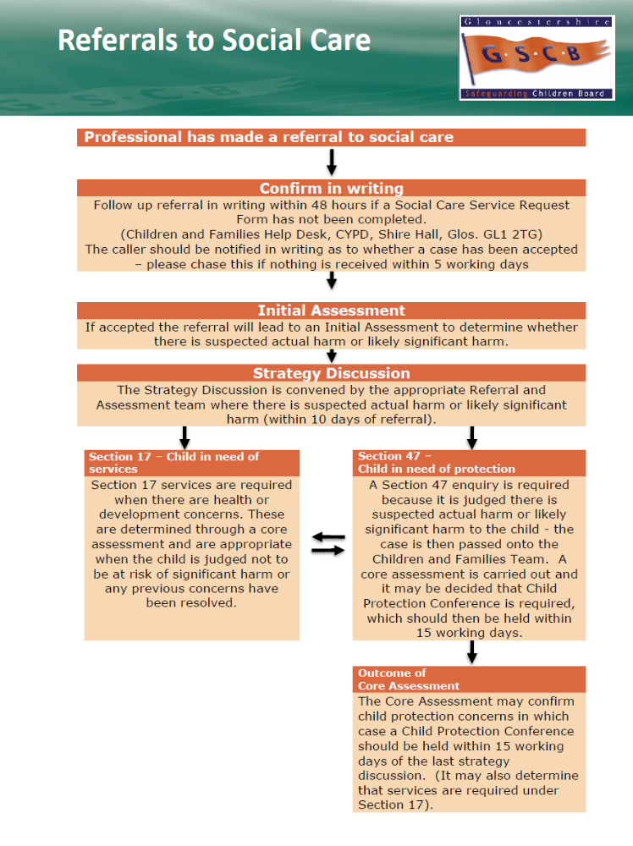

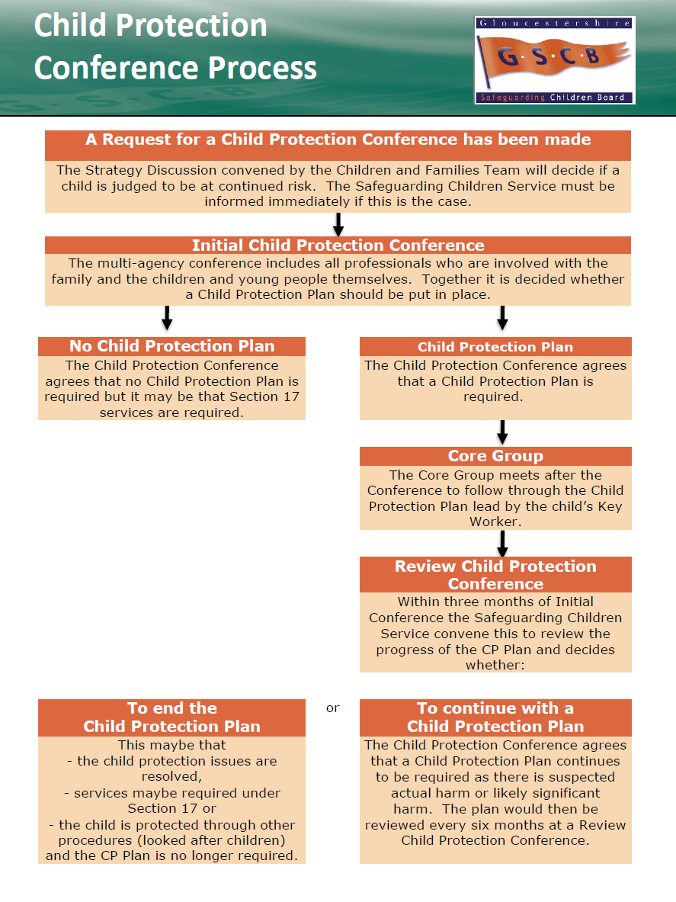
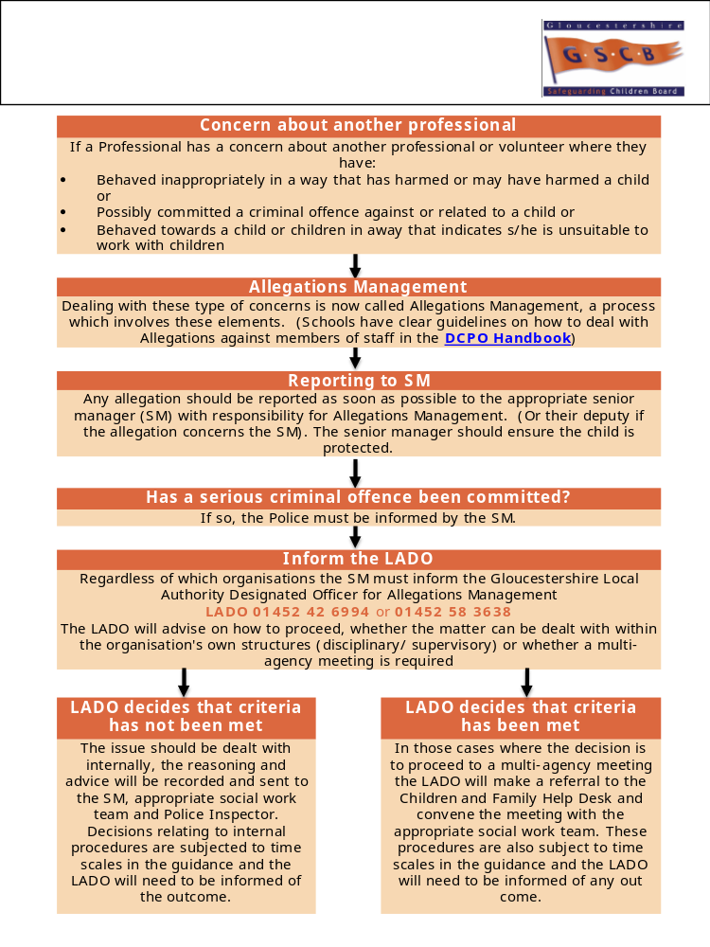

PERSONAL STANDARDS EXERCISE

Consider each item in turn. Alongside each statement put a “+” if you think it is healthy, or a“-“ if you think it is unhealthy.

- 13 year old boy is fostered by a gay man in his thirties.

- Both parents tell their children that they have lovers outside the marriage.

- Father inserts his fingers into his 3 year old daughter’s vagina while he is bathing her.

- Step brother and his friend barge into his step-sister’s bedroom.

- Parents forbid their 13 year old daughter from going out with boys because it is against their religion.

- Father shows his 11 year old daughter how to use a tampon.

- Parents allow 14 year old with learning difficulties to have sex education lessons.

- Parents tell their 8 year old son that it is OK to “play” with himself in his bedroom.

- Father has a bath with his 8 year old daughter.

- Both parents walk around the house with no clothes on.

- Father kisses his 13 year old daughter on the mouth when she goes to bed.

- Father refuses medical treatment for daughter who has aids.

- Father shows his daughter his sex organs to “educate” her.

- A 14 year old girl in foster care asks for school nurse for contraceptive advice.

- Father spanks his 8 year old daughter over his knee for a minor misdemeanour.

- Mother shows daughter how to use a tampon.

- Wife lets husband have sex with her, even though she doesn’t feel like it.

- Father asks daughter “what her boyfriend did to her” on her first date.

- 6 year old Irish child cared by a succession of relatives.

- Father and older brother make fun of 11 year old’s growing breasts.

- Parents refuse chemotherapy for 5 year old with cancer .

- Asian family arrange a marriage for their 15 year old son.

- Parents joke about their 8 year old son dressing up in girls clothes.

- Mother encourages 4 year old girl to use make-up and dress in adult fashions.

- Mother leaves children (aged 8 & 10) alone while she goes to the shops.

Some Dos and Don’ts

Do Be alert to signs of abuse and neglect. It can happen anywhere.

Do Be prepared to respond calmly. Children are more likely to allow you to help them if you are prepared to listen and appear not to panic.

Do Keep a clear record of your concerns and actions.

Do Make yourself aware of local procedures for responding to suspected abuse.

Do Consult Social Care if you are in any doubt.

Do Not Promise the child that you will not tell anyone else. Instead explain that to help them stop the abuse you will need to talk to other people.

Do Not Try to “go it alone”. Children are best protected when all agencies WORK TOGETHER.

